**1. What is the command to compile the files with extra symbols that are useful for GDB?**

gcc -g GDBassign.c blowfish.c

**2. What's the address of stuff?**

0x7fffffffc280: 0x00000000

**3. What's the address of stuff[0]?**

0x7fffffffc280: 0x00000000

**4. Do we expect these to be the same? Why? Explain what the [ ] operator does in C.**

They are expected to be the same as the pointer to the array will reference the first element of that array. The [ ] operator is short for *(ptr + i) where i is the index.

**5. In Blowfish_Init( ), what is the value of key?**

key=0x400ce0 "LAME_KEY"

**6. What command(s) did you type in order to learn this?**

break Blowfish_Init

run

print key

**7. In Blowfish_Init( ), what are the values of i and j after the nested for loops have finished? i.e., after:** i = 4, j = 256  
for (i = 0; i < 4; i++) {

for (j = 0; j < 256; j++)

ctx->S[i][j] = ORIG_S[i][j];

}

**8. What command(s) did you type in order to learn this?**

break blowfish.c:719

run

print i

print j

**9. Before the Blowfish_Encrypt function is called, what is the value of stuff[3] (for each, print the value, and the command used to obtain the value):**

|  |  |
| --- | --- |
| In hex? |  |
| In binary? |  |
| As a float? |  |
| As 4 chars? |  |

**10. Before the Blowfish_Encrypt function is called, what is the value of stuff if we treat it as a string? (You don't have to write the whole string. Just describe what's there.) What was the command typed in order to obtain this value?**

0x7fffffffc280: "Oh, who are the people in your neighborhood?\nIn your neighborhood? \n In your neighborhood? \n Say, who are the people in your neighborhood? \n The people that you meet each day \n \n [Anything Muppet #1: "... (the whole string is printed)

break a.out:385

run

x /s stuff

**11. What is the value of x the first time that the function F() in Blowfish.c is called?**

1753098189

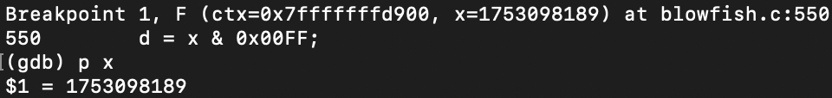

**12. What is the output if we run GDB's backtrace (abbreviated "bt") command inside the function F() in Blowfish.c the first time F() is called? Briefly explain the output of the command in your own words.**

After running backtrace inside F() for the first time, the addresses of the arguments of function F() as well as the value of each variable are displayed. The next one is Blowfish_Encrypt which contains function F()in its scope also shows its argument. Same thing for function Blowfish_Init that has Blowfish_Encrypt in its scope with the values of arguments and addresses. Each call even includes the number line and source file of relevant function calls.